THE LABORATORY MANAGERS ASSOCIATION OF SOUTH AUSTRALIA INC.
ABN: 45891413257
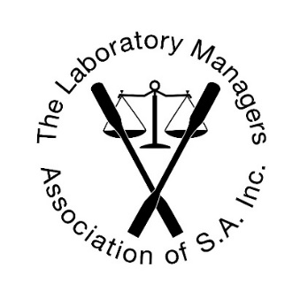

AGM Agenda 5th October 2022
Gawler & District College B-12, Barnet Road, Evanston

- Welcome

- Apologies

- Minutes of the previous AGM
Motion: “That the minutes of the AGM on 5th October 2021, be accepted.”

- President’s Report
Motion: “That the President’s Report be accepted.”

- Treasurer’s and Auditor’s Reports
Motion: “That the Treasurer’s and Auditor’s reports be accepted.”

- Appointment of Auditor for next financial year
Motion: “That Haydon Edwards continue as external auditor.”

- Award Presentations

- Election of Committee and Office Bearers

- Close

