LMASA ANNUAL CONFERENCE
4th-5th October 2022

DAY 1 – Recycling Tour with Jo Hendrikx, Resource Recovery Education Officer KESAB (sponsored by WOW = Wipe Out Waste)

Discussions on the bus:
- In the 1950’s – 1960’s most people had an incinerator in the backyard. Most paper or cardboard rubbish was burned. This was before single use plastic became available. Incinerators were subsequently banned, when it became unsafe to burn plastic-based rubbish.
- KESAB started in 2006
- Button style battery – add sticky tape to both sides to reduce the chance of fires
- Repair cafes – good addition to makerspace library spaces. Often items are easily repairable Ex vacuum cleaner thrown out when ‘not working’ but all that was wrong was that the hose was blocked.
- Remakery café & shop
- SA does recycling well ~= European standards. Pelican Point is the most efficient power station in the world. SA is quiet about these achievements. Unfortunately the rest of Australia is well behind.
- SA interconnector is not for SA but to allow NSW to turn off cola power plants
- only put out recycling bins when full - to save time & energy
- place egg cartons in the organics bin (poor quality paper)
- Cut a slip in a 2L plastic milk container to enable yoghurt & cream lids (or any other small plastic items) to be pushed through, otherwise they are too small & will fall through the machinery

YCA RECYCLING - 16-20 Johansson Road, Wingfield (plastic recycling)
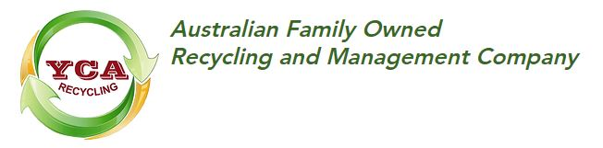https://www.ycarecycling.com/our-company

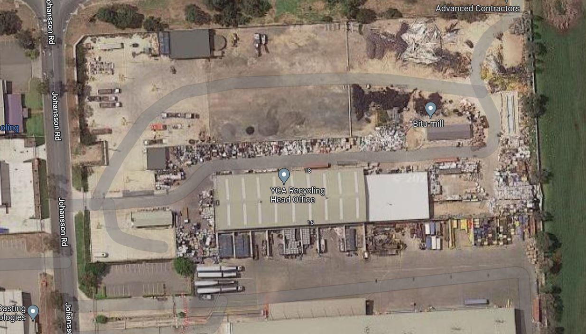
Recycle by sorting and pelletizing various plastics for reuse. Mainly commercial quantities of the same type of containers/single type of plastic eg Agricultural piping, irrigation hose, old wine containers, car bumpers, corflute, coffin handles, plastic drums but also some council sorted mixed plastics come here. Various pile with various plastic types. Plastic is granulated, washed, dried and bagged. Chemical drums are rinsed first. Plastic produces are mostly sold to local manufacturers. Processing 80 ton/week.

They also recycle some glass, including Pyrex but must be clean and dry, not contaminated.

There are bins by the office for general public to drop off items into the various bins.

Companies should have policies in place to buy recycled plastics.

The butterfly diagram: visualising the circular economy
The circular economy system diagram, known as the butterfly diagram, illustrates the continuous flow of materials in a circular economy. There are two main cycles – the technical cycle and the biological cycle. In the technical cycle, products and materials are kept in circulation through processes such as reuse, repair, remanufacture and recycling. In the biological cycle, the nutrients from biodegradable materials are returned to the Earth to regenerate nature.

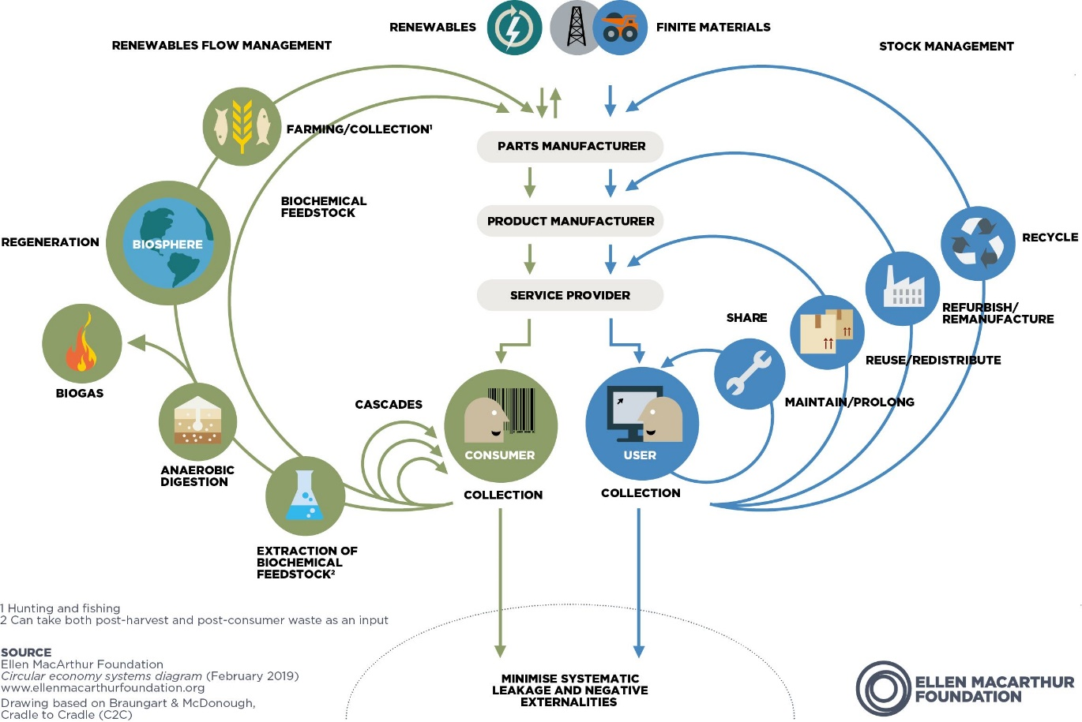

INTEGRATED WASTE SERVICES Lot 254 Hines Road, Wingfield
(waste transfer station)
https://www.iwsgroup.com.au/
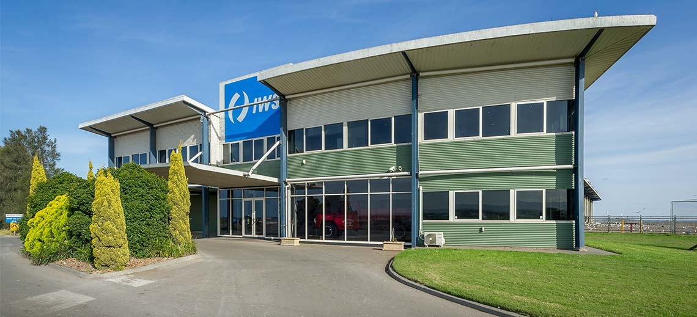
Offices & Education Centre

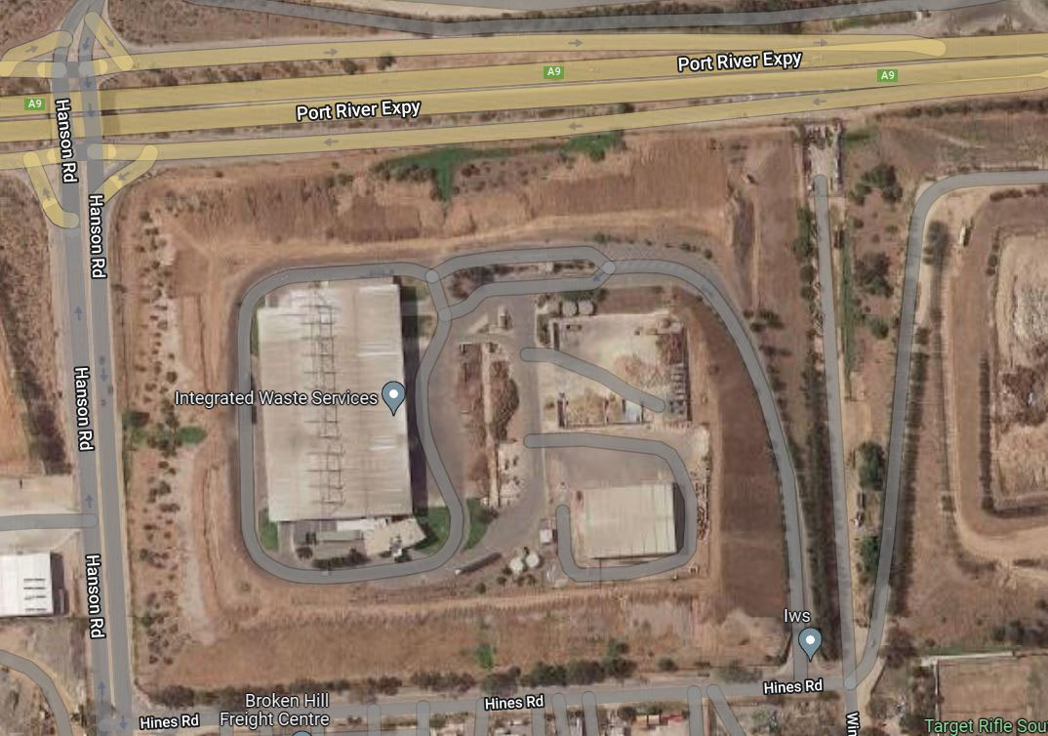
IWS platform visit and the KESAB Education Centre

Viewing Platform
Landfill bins deliver their loads here (or contaminated loads of recycling)

Green trumble at the back is sorting out food waste (heavier)

Veolia truck delivering commercial waste.

The pile at front is probably a contaminated recycling load

- Glass bottles & jars are best delivered to a 10c place to keep separate & clean.
- 50 -80 trucks a day
- indoor sorting to reduce dust, litter & birds
- Veolia & Suez have merged. Now only other company is Cleanaway.
- as much a possible is diverted to other recycling companies eg wood waste is converted by ResourceCo into Processed Engineered Fuels (PEF) which are used by Brighton Cement

JEFFRIES N/412 Hanson Rd, Wingfield SA 5013
(Green Bin recycling)
https://jeffries.com.au/commercial-recycling/

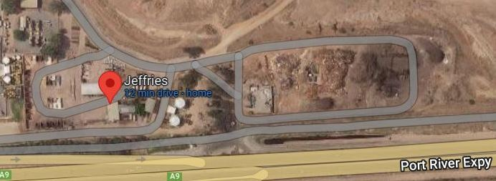

Green waste is sorted here into four streams:
- clean green (logs & stumps, branches, leaves and grass clippings and mulched material. tree and branch cuttings
- clean timber (pallets & crates, timber packaging and off-cuts, non-treated demolition, ply)
- food organics (organic liquid wastes, food scraps and organic left-overs)
- liquid organics (grease trap, stormwater/silt trap, directional boring (muddy water), liquid wine/beverage waste, DAF/trade waste, hatchery/tannery liquid waste

They receive 50,000 tonne per year from organics bins from half the councils in SA and commercial loads from cafes and restaurants etc, plus the occasional dead whales, and organic trade waste eg chicken carcasses, totaling 175,000 tonne per year.

Clean timber eg pallets are ground, screened to removed metal nails etc, and turned into mulches, some are dyed red, black or brown.

Compost is made at Buckland Park with pipes under the piles to give forced aeration, therefore less turning is required. Must achieve a 55ºC temperature, 3 times over a 60-day process. Once composted, it is sorted, and oversized pieces are reground for re-composting. 97% of contaminates are removed. Regularly tested to AS in EAL Lab in Sydney.

Fires can be a problem, but they have a comprehensive safety plan and view regularly & keep a check on the temperatures

Jeffries’ methane power plant produces enough power to light 8-10, 000 homes. The piles will keep producing for 20 years.

Jeffries also has a new $4 million, Biochar facility. It is made from curbside wood, which is reground and burnt with limited oxygen, to produce a type of charcoal by a process called pyrolysis. Biochar is rich in carbon and is lightweight and porous and so improves soil structure and its water and nutrient holding capacity. They sell Culchar and organic fertilizer with Biochar for the domestic garden. The plant also recovers steam, which is used to produce electricity to power the sight. These processes means Jeffries is a negative carbon productor, who can sell carbon credits.

VIDEOS
Jeffries Recycled Organics Sorting System used at Buckland Park
https://www.facebook.com/watch/?v=1537204452994779

Landline 2/10/22 on iView, at 40:49 minute mark. The 46:39 mark also shows the Jeffries compost making Buckland facility

Jeffries Spruiks Australia’s Biggest Biochar Plant
https://www.aumanufacturing.com.au/jeffries-spruiks-australias-biggest-biochar-plant

SIMS METAL - N Arm Road, Gillman
(metal recycling)
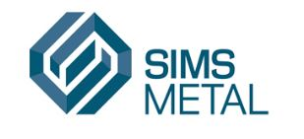

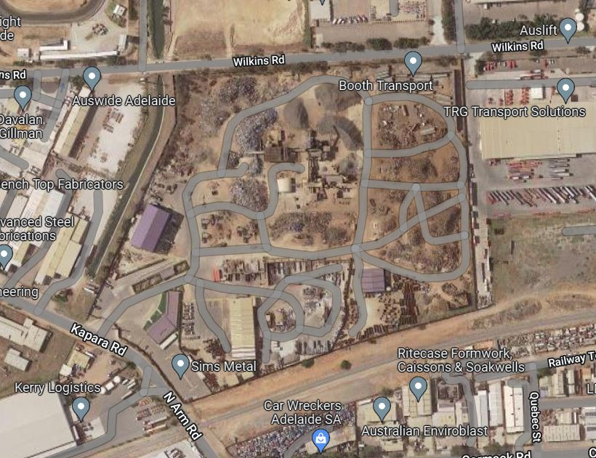

Largest metal recycler in the world, 4 yards in SA others in Aust & Worldwide

Metal sorted into
- Lightweight Ferrous – crusted and pelletized
- Heavy weight – cut into Contract sized pieces with oxyacetylene
- Non-ferrous metals eg Al, Cu, Stainless steel, brass, (these kept behind barbed wire)
- Non-metal waste

117 employee, 2 shifts:
- 7am – 3.30pm Working shift
- 2.30pm -011pm Maintenance
Fire risk, particularly the non-metal waste which is removed daily. No explosions (neighbors don’t like it) only blast overs!
RESOURCES
Interactive guided tour of one of the processing facilities www.kesab.asn.au/simsmm/

A range of curriculum-linked lesson ideas and accompanying worksheets to educate primary and middle years students about metals and the metal recycling process.
http://www.kesab.asn.au/simsmm/for-educators/lesson-ideas-worksheets/

ELECTRONIC RECYCLING AUSTRALIA - 301 Grand Junction Rd, Ottoway - (electronic recycling)
https://www.electronicrecyclingaustralia.com.au/

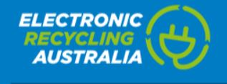

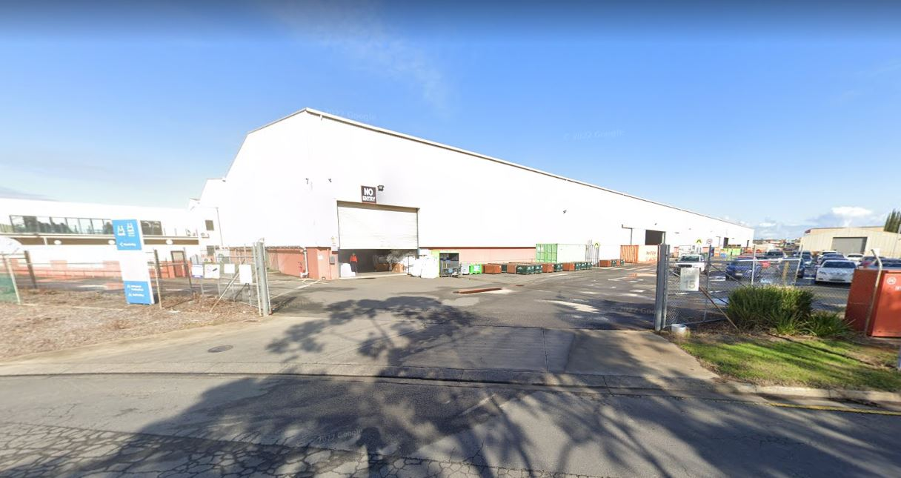

Electronic Recycling Australia is an initiative of Minda Inc. Minda is a major employer of supported workers across its highly successful range of commercial enterprises, including ERA.

Computers, TV’s etc are pulled apart and components separated for reselling and waste recovery. Cables are shredded and sorted into copper dust and plastic pieces. Bins by the gate for drop-offs or Bunnings.

Mattresses are stripped under the Bounce Back program. The metal is recycled, and the foams are sold to make carpet underlay.

EPS ie Polystyrene foam is melted and sold for reuse. Bins are available for the public to drop off stuff. All paper, labels & sticky tape must be removed first. Yoghurt & cream containers are often made out of polystyrene.

Can also drop off Lithium-Ion or Lead Acid batteries.

BIOBAG 352-356 Richmond Rd, Netley
(plastic alternatives)
https://biobagworld.com.au/

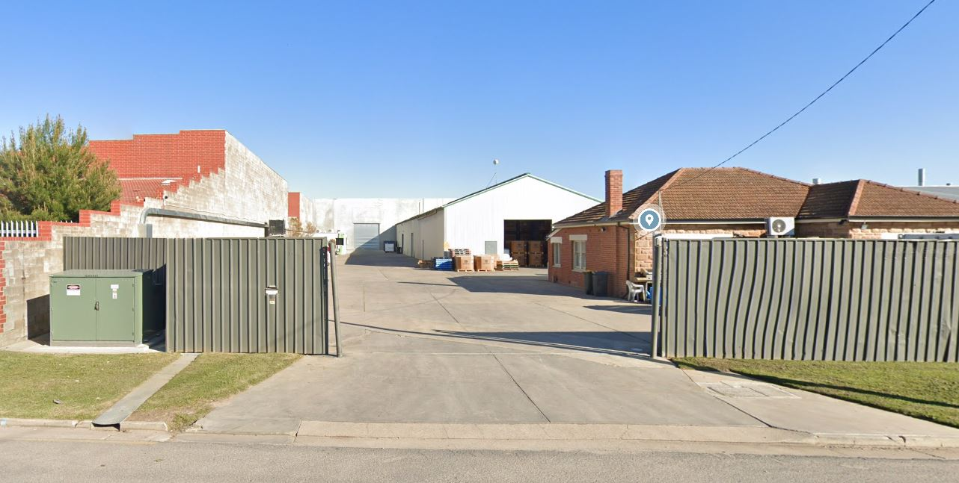

Biobags make composting bags, poo bags and mulch films, using starch based compostable platic.

Italian made plastic made from potato or corn starch, and vegetable oils. ~ 20 different recipes.

OTHER RESOURCES

Which Bin?
https://www.whichbin.sa.gov.au/
or phone: 1300 137 118

WHICH BIN TIPS – all their tips are worth reading, to ensure high quality recycling
https://www.whichbin.sa.gov.au/tips

What do the numbers on plastics really mean?
https://www.whichbin.sa.gov.au/tips/deciphering-the-plastic-codes-what-do-the-numbers-on-plastics-really-mean-are-they-recyclable

Recycling Bins Available at Officeworks
https://www.officeworks.com.au/information/about-us/peopleandplanet/recycling
includes CD’s, DVD’s, USB’s and hard drives\

SRWRA – Southern Region Waste Resource Authority
https://srwra.com.au/

Southern Materials Recovery Facility
https://srwra.com.au/southern-materials-recovery-facility/

NAWMA – Northern Area Waste Resource Authority
https://www.nawma.sa.gov.au/

How the NAWMA Material Recovery Facility (MRF) works
https://www.nawma.sa.gov.au/wp-content/uploads/2020/07/NAWMA0078_MRF_DL_Brochure.pdf

CAWRA - Central Adelaide Waste and Recycling Authority
In a first for South Australia, the MRF will include a modern and interactive education centre incorporating a full-length glass viewing wall and an elevated walkway, which will give school and community groups a unique close-up view of the entire recycling process.

