Make Your Own Paper

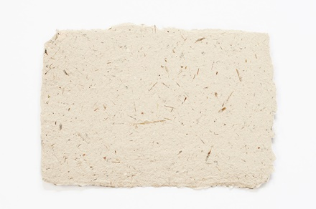
https://www.eekwi.org/activities/arts-crafts/make-your-own-paper#:~:text=What%20to%20Do%3A,in%20the%20starch%20

What happens to used paper? Most paper is thrown away in landfills or is burned. If we recycle paper we save landfill space and use these valuable wood fibres again. Don't throw away that old newspaper, office paper or unwanted wrapping paper, turn it into a piece of art by making new paper with it.

Making your own paper from old paper is similar to what happens in a paper recycling mill. At a mill, the pulp is put into a machine with a long moving screen. The water drips through the screen. Then the screen moves through part of the machine that presses and dries the pulp. Now you have paper.

The paper you will be making will be much thicker and rougher than the recycled paper made at a mill. Paper mills have several machines to make the paper smooth and flat. We can't do this at home.

Here is what you will need:
- blender or egg-beater
- mixing bowl
- flat dish or pan (25cm x 33cm or a little larger than the screen)
- round jar or rolling pin
- newsprint, scrap paper or wrapping paper
- piece of non-rusting screen (about 30cm X 20cm or the size of paper you want to make)
- 4 pieces of cloth or felt to use as blotting paper (same size as screen)
- 10 pieces of newspaper for blotting
- 2 cups of hot water
- 2 teaspoons of instant starch (optional)
What to Do:
- Tear the newspaper, scrap paper, or wrapping paper into very small bits. Add 2 cups of hot water to ½ cup of shredded paper.
- Beat the paper and water in the blender, or with the egg-beater, to make pulp. Mix in the starch (optional). Completed pulp should be the consistency of split pea soup.
- Pour the pulp into the flat pan.
- Slide the screen into the bottom of the pan and move it around until it is evenly covered with pulp.
- Lift the screen out of the pan carefully. Hold it level and let it drain for a minute.
- Put the screen, pulp-side up, on a blotter that is placed on top of newspaper. Put another blotter over the pulp, and more newspaper over that.
- Roll a jar or rolling pin over the "sandwich" of blotter paper to squeeze out the rest of the water.
- Take off the top newspaper. Flip the blotter and the screen very carefully. Do not move the pulp, it will take at least 12 to 24 hours to dry depending on how thick and wet the paper is. Wow!! There is your own hand-made paper! (If you have leftover pulp, don't pour it down the drain--you might clog things up. Put it in the compost bin.)
- Try this again and use some decorative elements such as coloured thread, glitter, dried flowers and leaves to add some flair. Now you can make cards or note paper out of your newly created paper.

