RECYCLING

Paper & Cardboard | Green Organic Waste | Council Recycling  eg tins, jars, milk cartons | Small Plastic Items  eg lids | Al  Foil | Soft plastics  eg Gladwrap, plastic bags, | Batteries | Pens & Textas
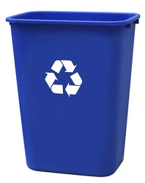 | 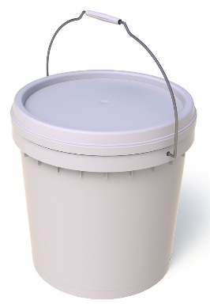  Organic Waste | 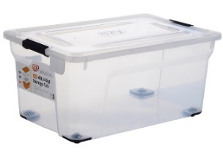 | 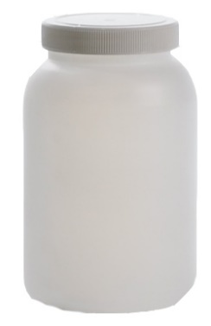  Small plastic items | 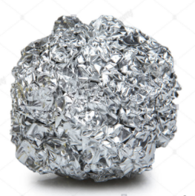  Combine into  a ball | 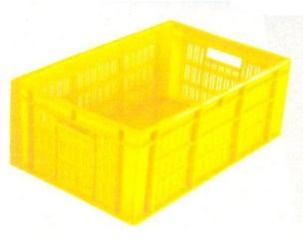 | 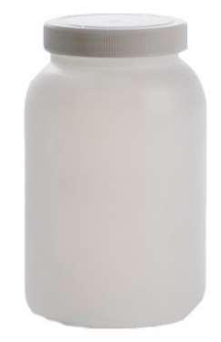  Batteries | Pens
In each classroom | In A25 | Under fume cupboard in A25 | Under fume cupboard in A25 | Under fume cupboard in  A25 | Under fume cupboard in A25 | Under fume cupboard in A25 | Under fume cupboard in A25
Collected Weekly | Taken Home on Friday | Taken to Large Council Recycling Bin When Full | Put into Council Recycling Bin | Put into Council Recycling Bin | Taken to Supermarket | Taken to Bin in SSO | Taken to Officeworks

