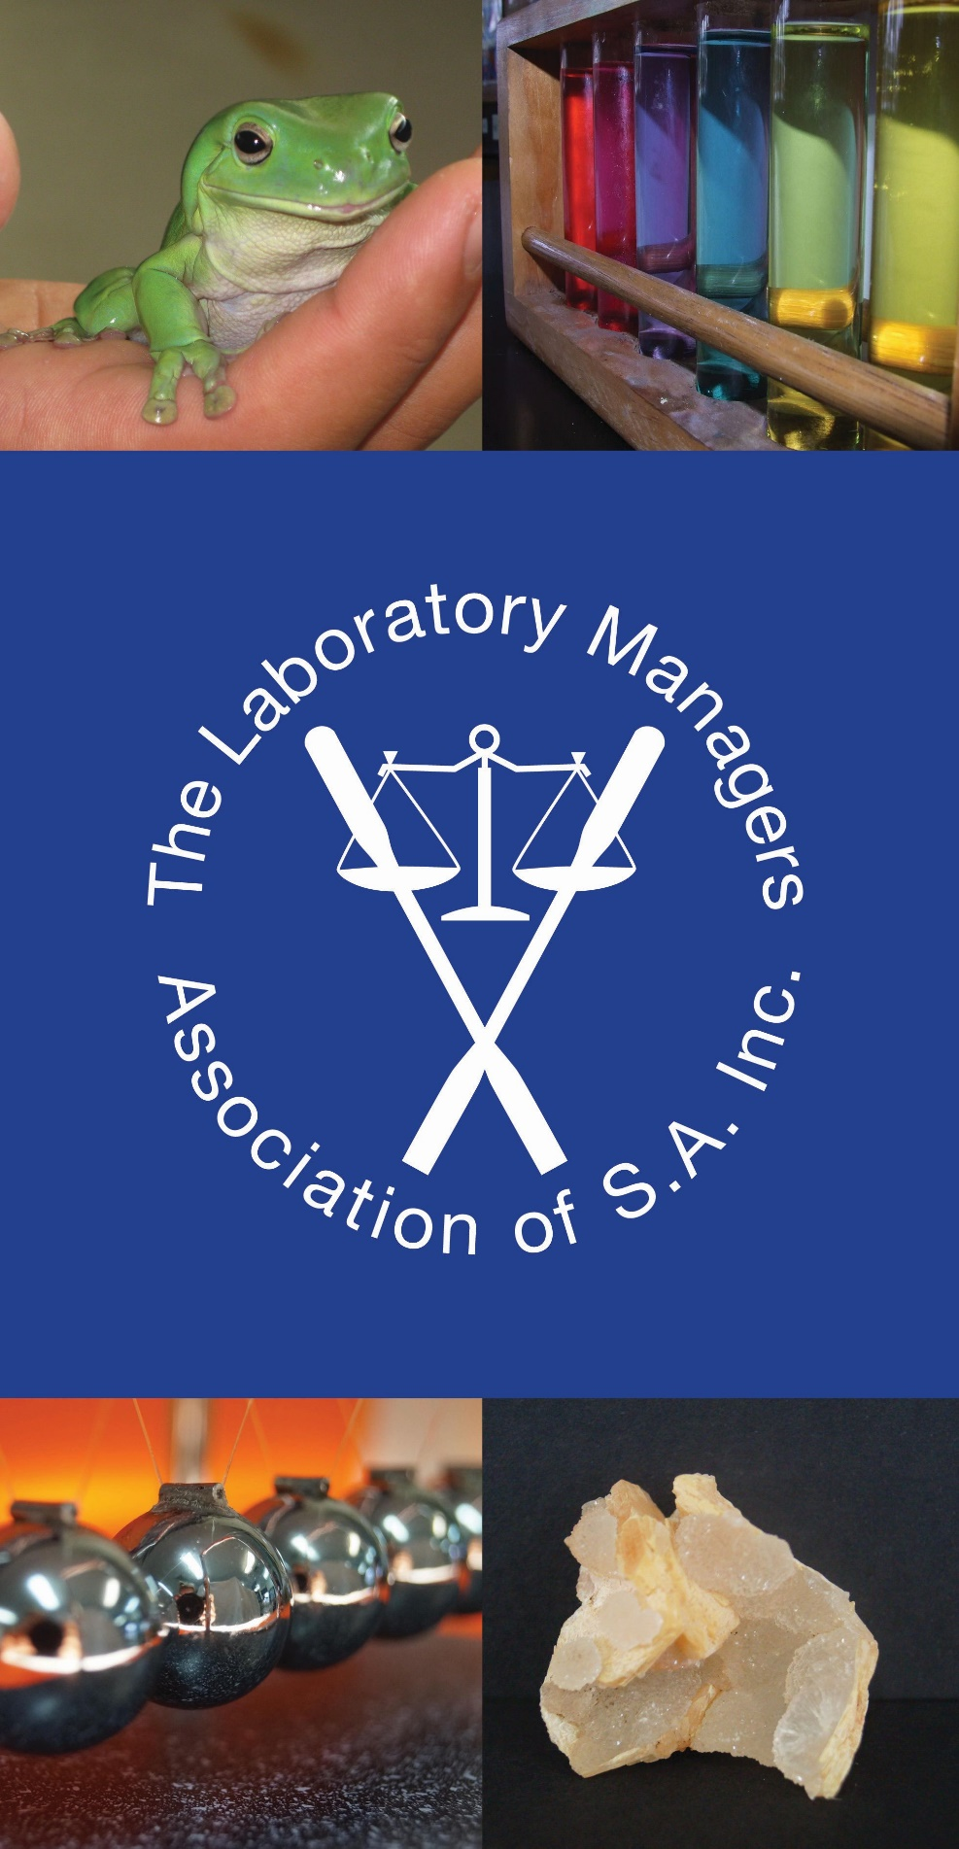

MEMBER INFORMATION BOOKLET
TABLE OF CONTENTS

Welcome Message from the President 3

Mission Statement, Object and Purpose 3

Contact Details for the 2021 Committee 4

Hub Groups 5

Contact Details for Hub Groups Leaders 5

WHS Training Day 5

Annual Conference 6

Membership & EdSA Gateway 6

Google Groups Forum 7

Google Groups Webpage & Archives 8

To Access our Webpages 8

Constitution 8

Policies 9

WELCOME MESSAGE FROM THE PRESIDENT
Welcome to the Laboratory Manager’s Association of South Australia Inc (LMASA). Whether you are new to the science facilities in the education system or well versed in the working of a science laboratory we are here to support you.

The Laboratory Managers Association of South Australia Inc. was formed in 1994 to facilitate training, education and development of members and to assist in communicating ideas and information. The Association is open to all persons working as Science laboratory personnel in the education environment in both State and Independent schools, in South Australia (and the Northern Territory).

The Association is run by members for members. An elected committee of volunteers, meets on the second Monday of each Term at the Education Development Centre.

The association is affiliated with Educators SA (EdSA) and Science Education Technicians Australia (SETA).

Please read the information below to find out more.

Jacki Victory
President
Laboratory Managers Association of SA Inc

MISSION STATEMENT
The Laboratory Managers Association of South Australia Inc.:
- fosters mutual support and sharing of members knowledge and experience
- promotes networking and PD opportunities
- and empowers members
to provide safe and positive outcomes that enhance Science education.

We believe that laboratory personnel are integral in improved student outcomes.
By providing technical support to teachers and students we encourage the exploration of the sciences. We model and encourage safe work practices.

OBJECT AND PURPOSE
- To act as a support for members
- To facilitate Training, Education and Development
- To assist in communicating ideas and information

2023 COMMITTEE

PRESIDENT
Jacki Victory
Gawler & District College B-12
Barnet Rd
EVANSTON SA 5116
Phone: (08) 8521 2400
Fax: (08) 8523 0439
Email: jacki.victory678@schools.sa.edu.au

VICE PRESIDENT:
Sheryl Hoffmann
Concordia College
24 Winchester St
HIGHGATE SA 5063
Phone: 8291 9325 (direct)
8272 0444 (school)
Fax: -
Email: shoffmann@concordia.sa.edu.au

SECRETARY
Margaret Boyle
Phone: 0438 469 617
Email: obawo55@gmail.com

TREASURER & PUBLIC OFFICER:
Rianne Wright
Immanuel College
32 Morphett Rd
NOVAR GARDENS SA 5040
Phone: 8375 1700
Fax: 8294 2658
Email: rwright@immanuel.sa.edu.au

MEMBERS:
Jane Hosking
St Francis de Sales College
8 Dutton Rd
Mt BARKER SA 5251
Phone: 8393 1000
Email jhosking@stfrancis.catholic.edu.au

Sarah Boyle
St Dominic's Priory College
139 Molesworth Street
North Adelaide SA 5006
Phone: 8267 3818
Fax: 8267 4877
Email: seboyle@live.com.au

Pranay Sharma
The University of Adelaide College
132 Grenfell St
Adelaide SA 5000
Phone: 8313 3430
Email: pranay.sharma@adelaide.edu.au

Alex Cowling
Craigmore High School
2 Jamieson Rd
Elizabeth Downs SA 5113
Phone: 8254 6522
Email: alex.cowling747@schools.sa.edu.au

HUB GROUPS
We have 3 Hub Groups:
- Northern
- Eastern & Hills
- Southern & Western

All Hub Groups are open to both members & non-members. People can choose to go to the one closest to their school, the one closest to home or even go to all of them.

Each Hub Group operates a little differently, but you can expect guest speakers, workshops, visits to different host schools, a chance to have problems solved if a practical is not working and a chance to swap unused items for needed ones. The meetings are always a great opportunity to network and meet others in the same job.

There are 1 or 2 events each semester for each Hub Group and events are usually advertised on our Google Groups Forum.

If you wish to contact a Hub Group Coordinator their contact details follow:

Northern Region:
Alex Cowling
Craigmore High School
Ph: 8254 6522
Email: alex.cowling747@schools.sa.edu.au

Southern & Western Region:
Zena Hickling
Tatachilla Lutherna College
211 Tatachilla Road, McLaren Vale
South Australia 5171
Ph: 8323 9588
email: zena.hickling@tatachilla.sa.edu.au

or
Rianne Wright
Immanuel College
32 Morphett Rd
NOVAR GARDENS SA 5040
Ph: 8375 1700
Email: rwright@immanuel.sa.edu.au

Eastern & Hills Region:
Jane Hosking
St Francis de Sales College
8 Dutton Rd
Mt BARKER SA 5251
Phone: 8393 1000
Email jhosking@stfrancis.catholic.edu.au
WHS TRAINING DAY
Each Year we hold a WHS Training Day for members only. It is held in the April holidays, usually on the Wednesday adjacent to the Science Teachers Association of SA (SASTA) Conference, so that people coming from the country can attend both.

Our WHS Training Days have guest speakers covering such topics as:
- Disposal of Chemical Waste
- Storage of Hazardous Chemicals
- Labelling of Hazardous Substances
- Chemwatch
- What can go down the sink
- Reading a SDS
- SafeWork Library
- Electrical Testing & Tagging
- Safety & Rocks
- Radiation Safety
- Fire & Other Emergencies
- Ergonomics & Injury Prevention
- Workstation Stretches
- Foot Care
- Wellbeing

These days are fully catered with morning tea and a light lunch.

ANNUAL CONFERENCE
Each year we have an annual conference. On even years the conference is held for two days in Adelaide or near surrounds, and on odd years the conference is a three day excursion showcasing a specific country region. Country areas previously covered include:
- Coorong
- Barossa valley
- Mid-North – Burra
- Copper Coast – Moonta
- Limestone Coast
- Fleurieu Peninsula
- Riverland
- Kangaroo Island

Conferences often visit sites of scientific interest not normally open to the general public and may include places that would make good school excursions. We hold our AGM during the conference and have plenty of networking opportunities and they always feature plenty of good food.

Country conference registration include meals, accommodation, bus fares and entrance fees. City conferences registration include morning teas, lunches and entrance fees. All are good value for money and provide valuable learning experiences.
MEMBERSHIP & EdSA GATEWAY
Membership is currently $60 per year, due 1st January.

The LMASA uses an online membership system called “EdSA Gateway”. The system is hosted by Educators SA, the umbrella organisation for all education associations, of which we are member.

You can access the system at any time to check your membership status or to change your school or contact details. The system will also send you a reminder, when your membership is due.

The membership gate way can be found at: https://edsagateway.com.au/members/lmasa

GOOGLE GROUPS FORUM
The Laboratory Managers Association has an email distribution list hosted by Google Groups. This is separately managed from the Gateway. Members will need to contact rwright@immanuel.sa.edu to be added to this forum

All new members will have their school email address added to Google Groups and will receive a confirmation email from Google Groups saying they have been added.

To send to the list just send an email to lmasa@googlegroups.com or you may reply to another email, but please change the subject heading, if it is a different topic.

Points To Remember:

- Please remember that your email will go out to 180+ members so please use the system thoughtfully.

- If you want to reply to one or two people only, please don’t use the list. Instead forward your reply to the appropriate individuals.

- Please start a new topic with a new email rather than replying to a previous email, this makes topics easier to find in the archives.

- Never forward an email or conversation stream to a non-member.

- Please ensure that all contributions are work related. Sorry but this means no jokes or ‘fun’ postings.

- Contributions must be treated as confidential unless otherwise stated. The information provided is for members use only.

- Information shared is the opinion of the sender and not necessarily the opinion of LMASA.

- Contributions to Google Groups should not:
- use obscene language (nor replace individual letters with other symbols)
- harass, insult or attack others
- be defamatory
- involve or advocate illegal activities
- violate human rights
- contravene copyright laws (All contributions should be the members’ own work, or they must have permission to share it. All sources and quotes must be referenced)
- display offensive and pornographic images
- harm or disturb Lists or Groups members (No chain emails, do not use the email distribution list for emails directed to only 1-2 people)
- have depictions that condone or incite violence, particularly sexual violence
- portray any person in a demeaning manner. (Do not name teachers, or suppliers by name if complaining, nor complain about teachers in general.)
- be used for commercial purposes nor any third person that might benefit commercially from information that has been shared.
- do anything that would give rise to criminal or civil liability for either yourself or Education Services Australia Limited;
- harvest or collect email addresses or other personal information;
- impersonate any person or entity, or falsely state or otherwise misrepresent yourself;
- upload, post, transmit, share or otherwise make available any material that contains software viruses or any other computer code, files or programs designed to interrupt, destroy or limit the functionality of any computer software or hardware or telecommunications.
- Members can only post to the list from the email address added to the system. This means if you attempt to use an alternate address the system won’t recognise you and will tell you that you are not a member and hence not allowed to post to the list.

Members should refer to our ICT Policy for further information.

If you have a problem
Please contact Sheryl Hoffmann at shoffmann@concordia.sa.edu.au or 8291 9325.

GOOGLE GROUPS WEBPAGE & ARCHIVES
You can just use the Google Groups Forum as described above or you can access it as a webpage and view the archives, change your profile or send an email to the list.

For details on how to access our Google Groups Webpage please see the file LMASA Google Groups Webpage and Archives under Policies on our webpage listed below.

Please note that the archives are only available to you, from the date you joined Google Groups.

TO ACCESS OUR WEBPAGES
Unfortunately, our old webpages no longer exist. We are searching for a suitable new one and will inform all members when it goes live. Until then we have basic information at https://lmasa.weebly.com/

CONSTITUTION
The Constitution describes the purpose of the Association, who is eligible for membership, how the Committee works and the proceedings for General Meetings.

The Constitution can be found on our webpage. Please read the Constitution so that you know your responsibilities, as a member.

POLICIES
We have 4 policies that all members are required to abide by:
- ICT Policy
- Awards Policy
- Grievance Policy
- Privacy Policy

The Policies can be found on our webpage. Please read these policies so that you know your responsibilities, as a member.

